Space reserved for DTRS13 logo and information
4 spaces (1.5 spacing)

-------- (appx. 5.5 cm/2” from top of sheet)
Title of paper: Aligned left 16 pt. bold

Author 1ª, Author 2^{b}, Author 3ª, etc.
ª Affiliation and email
^{b} Affiliation and email

Abstract. 11 pt. 10 lines max. 1.15 spacing, single paragraph. Start text on same line.

Keywords: 11 pt. Up to five keywords, alphabetic order, 1.15 spacing.

- First section title (often Introduction, but not necessarily). Indent text 6 mm/1/4”.
Start here the text of section 1. As you work your way down, indent each new paragraph by 6 mm/1/4”. Do not leave a blank line between paragraphs. If section title happens to be at the bottom of a page, carry it over to the next page.
The second paragraph starts here.

  - This is a subsection title
Try to not include sub-subsections (e.g., 1.1.1). If you must do so, use the following format:
    - Title of sub-subsection. Start your paragraph on the same line. Title, like text, is 11 pt. Title in italic, but is not bold. No blank line before sub-subsection.

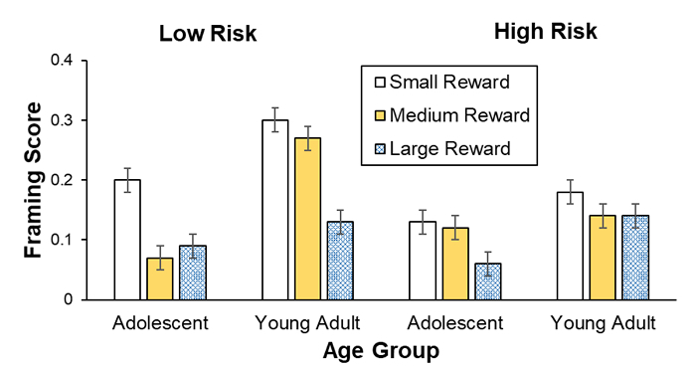
Figure 1. Title of figure. 10 pt., 1.15 spacing. Make sure text is legible, a legend is included if applicable, and credit is given to a source if applicable. Refer to figures in the text. If title happens to cross to next page, as in this example, do one of the following: a) Reduce figure if legibility allows, to “lift” title to same page. b) change location of figure, so title appears under the figure on the same page.

Table 2. Title of table. 10 pt., 1.15 spacing. Make sure text in the table is legible.

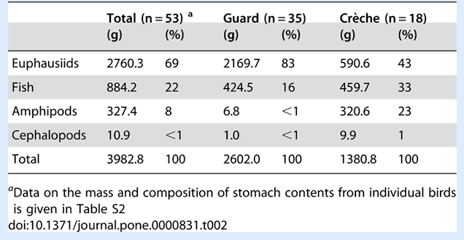

Acknowledgment(s)
Add acknowledgments as required.

References
Use these examples as guidelines for papers in journals, books, book chapters, conference proceedings, and so on. If in doubt, please consult guidelines for authors on the website of Design Studies. Please make sure all references are complete and follow the style very meticulously.

Cross, N. (2018). Expertise in professional design. In K. A. Ericsson, R. R. Hoffmann, A. Kozbelt, & M. A. Williams (eds.). Cambridge handbook of expertise and expert performance (2nd ed.), pp. 372–388. ‬‬‬‬‬ Cambridge University Press‬.‬‬‬‬‬‬‬‬‬‬‬‬‬‬‬‬
IDEO (2015). The field guide to human-centered design. IDEO.org. Available at https://www.designkit.org/, Retrieved on 20/06/2021.
Roozenburg, N. F. M., & Eekels, J. (1995). Product design: Fundamentals and methods. John Wiley & Sons.
Shen, W., Hommel, B., Yuan, Y., Chang, L., & Zhang, W. (2018). Risk-taking and creativity: Convergent, but not divergent thinking is better in low-risk takers. Creativity Research Journal, 30(2), 224-231.
Srinivasan, V., Chakrabarti, A., & Lindemann, U. (2012). A framework for describing functions in design. In Proceedings of International Design Conference DESIGN 2012, pp. 1111-1121. Dubrovnik, Croatia, May 21-24, 2012.
Sutton, R. I., & Hargadon, A. (1996). Brainstorming groups in context: Effectiveness in a product design Firm. Administrative Quarterly, 41(4), 685-718.
Tjalve, E. (1979). A short course in industrial design. Butterworth & Co.

